|  |
| --- |
| [Company name] |
| Sharing |
| [Document subtitle] |

|  |
| --- |
| Steven Renders  [Date] |

Table of Contents

Step 05 Sharing 2

Share your Dashboard 2

Create a Content Pack 4

# Step 05 Sharing

## Share your Dashboard

On the Power BI website, at the right top, select the Share button:

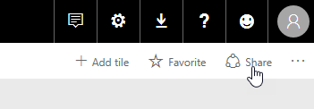

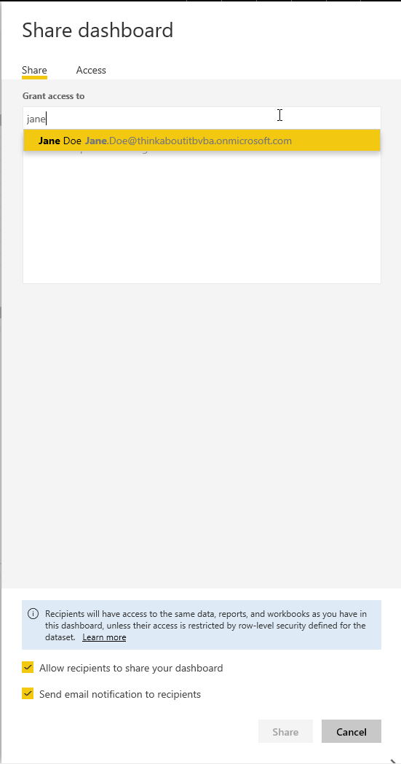

Type in the name or email address of a coworker you want to share the dashboard with.

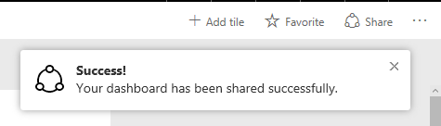

## Create a Content Pack

To create a content pack use the settings button:

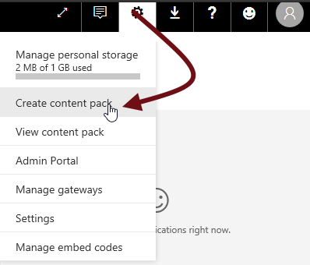

Enter the email (or name) of the person you want to have access to the content pack, and select the report(s), dashboard(s) and dataset(s):

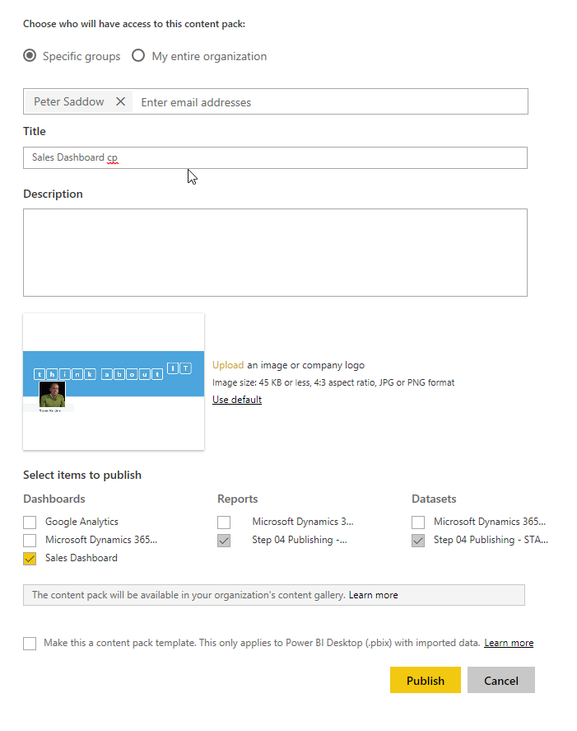

Creating content packs is a Pro feature, but you can try it out for free:

